Project Development Phase
Model Performance Test

Date | 17 February 2026
Team ID | LVIP2026TMIDSB7385
Project Name | AI Travel Itinerary Generator using Streamlit & Gemini API
Maximum Marks | 4 Marks

Model Performance Testing:
Project team shall fill the following information in model performance testing template.
S.No. | Parameter | Values | Screenshot
 | Model Summary | Pre-trained Generative AI model (Gemini Flash) used via API to generate structured travel itineraries based on user prompts and trip parameter | 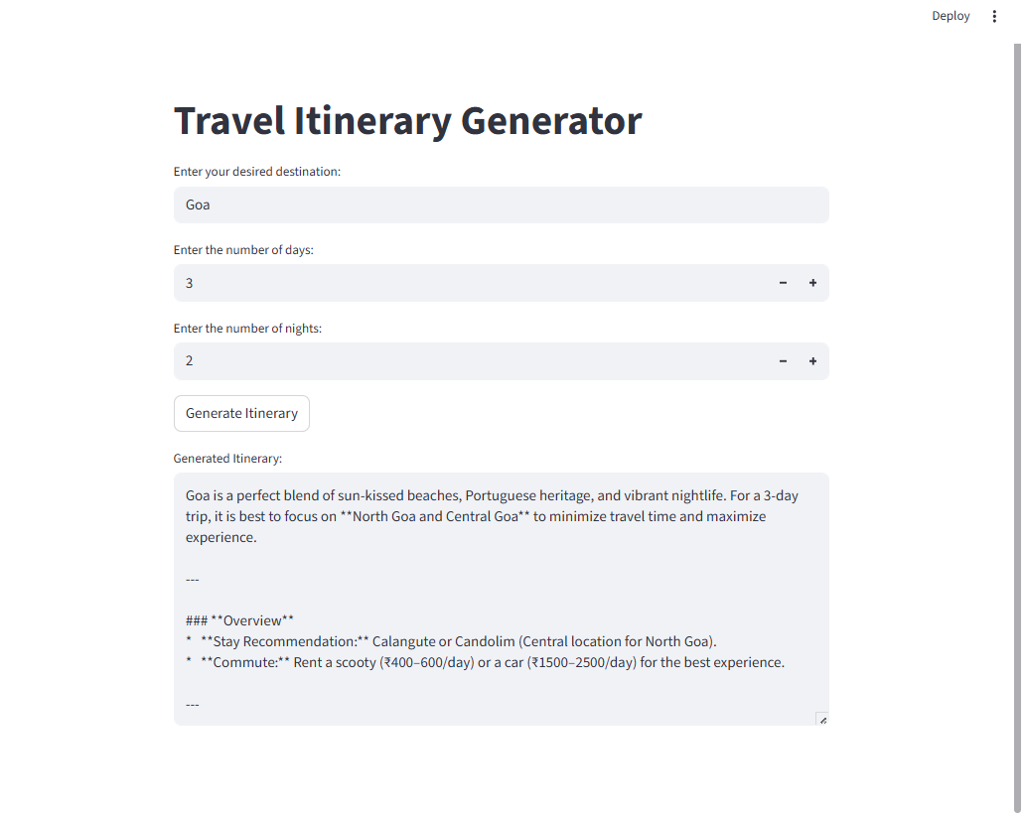
 | Accuracy | Output relevance tested across multiple destinations and durations. Generated itineraries matched user inputs and constraints in most test cases | 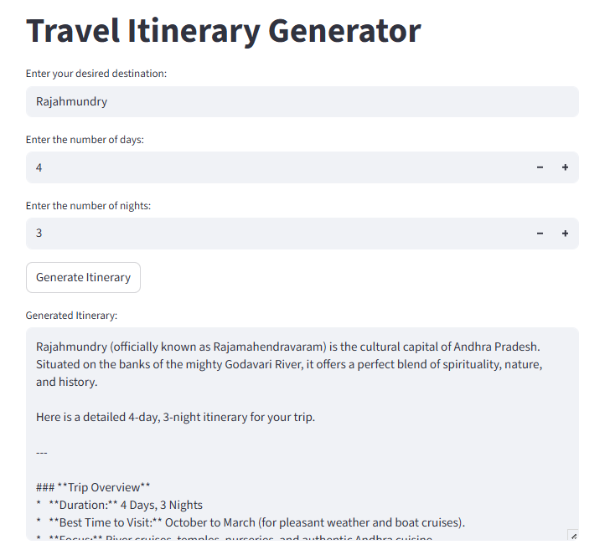
3. | Fine Tunning Result( if Done) | No fine-tuning performed. Used base pretrained model with prompt engineering for better results | NA

